**Problem 05:**

**Remove Nth Node From End of List**

Given the head of a linked list, remove the nth node from the end of the list and return its head.

**Example 1:**

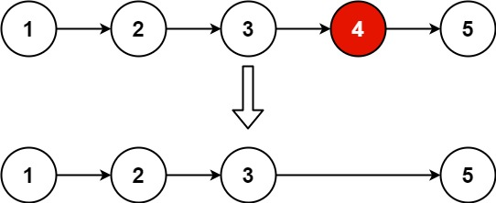

**Input:** head = [1,2,3,4,5], n = 2

**Output:** [1,2,3,5]

**Example 2:**

**Input:** head = [1], n = 1

**Output:** []

**Example 3:**

**Input:** head = [1,2], n = 1

**Output:** [1]

**Constraints:**

* The number of nodes in the list is sz.
* 1 <= sz <= 30
* 0 <= Node.val <= 100
* 1 <= n <= sz

**CODE:**

class Solution {

public ListNode removeNthFromEnd(ListNode head, int n) {

ListNode a = new ListNode(0);

a.next = head;

int len = 0;

ListNode first = head;

while (first != null) {

len++;

first = first.next;

}

len = len - n;

first = a;

while (len > 0) {

len--;

first = first.next;

}

first.next = first.next.next;

return a.next;

}

}